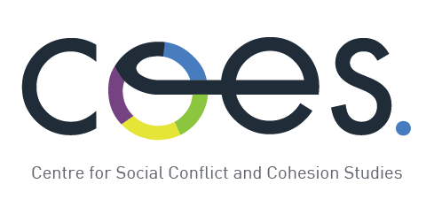
www.coes.cl

COES - Centre for Social Conflict and Cohesion Studies

Postdoctoral Research Positions at the Centre for Social Conflict and Cohesion Studies, at the Universidad de Chile, Pontificia Universidad Católica de Chile, Universidad Adolfo Ibáñez and Universidad Diego Portales.

The Centre for Social Conflict and Cohesion Studies (COES) invites applications for postdoctoral research positions. COES is a multidisciplinary Centre that aims to produce cutting edge research on conflicts and social cohesion in Chile as well as in the Latin American region, based on different conceptual and methodological contributions from the social sciences.Our work also aims to stimulate public debate and awareness as well as inform public policymaking with evidenced based research.

The Centre is looking for candidates to develop their research in the following areas:
- the socio-economic dimensions of conflict
- group and individual interactions
- social and political conflict
- the geographies of conflict

In this call, COES emphasizes these areas:

- Longitudinal Studies
- A theoretical contribution in cohesion and conflict concepts
- Spatial dynamics of conflict and social cohesion: with a most important emphasis in central and/or local public governance and public policy research agenda’s linked to chilean cities or at least Latin-American cities, and also interested in spatial modeling propositions.
- Migration
- Ethnicities
- Gender
- Sustainable Development

COES invites applications for postdoctoral research position in disciplines like sociology, psychology, urbanism, geographic, economics, political science, history, anthropology, among others. You can see other postdoctoral positionsatwww.coes.cl.

Qualified candidates must have a PhD(awarded within the last 5 yearsor an approved PhD thesis with graduation pending) in one of the social sciences as well as strong writing and methodological skills. They should possess expertise in topics that fit into the Centre’s research agenda such as social movements, social theory,political socialization, social stratification, intergroup relations, social identity and intergroup contact, multidimensional inequalities,segregation, urban conflict; territorial inequality, among others (You can see a project list athttp://coes.cl/blog/noticias/proyectos-de-investigacion-coes-2014-2/). In addition to the completion and publication of their own research, the postdoctoral scholars’ primary responsibilities will be planning and conducting studies, statistical data analysis and preparation of manuscripts for publication and conference presentations.They will also be expected to be actively involvedin developing and publishing articles.Selected candidateswill be able to undertake some teaching in English or Spanish. They will work collaboratively with a multidisciplinary research team of social scientists led by Professor Dante Contreras.

The salary offered for this position is US$ 30,000 per year approximately (precise amounts may vary depending on exchange rates).Each position is for two years, but renewal for the second year will be subject to the fulfilment of objectives.

We also welcome applications from post-docs who would like to undertake a joint post-doc with another Chilean or international partner institution. In this case, partner institutions will share in the cost of the post-doc appointment, and candidates may reside in another country as well as Chile.

Applications are open until June 30, 2016. Please send a motivational letter, curriculum vitae, summary of Ph.D. research, brief research proposal (no more than two pages) and two letters of support to contacto@coes.cl.Interviews with the selection committee could also be by telephone or through video conference.



