We are looking for a LOGISTICS MANAGER who


- Plans, administers and coordinates all relative to warehouse and shipping tasks to achieve cost efficiency and meet quality standards in all company’s facilities.
- Supervises human resources aiming to excel performance, productivity and profitability through the implementation of effective methods and strategies.
- Undertakes personally operational tasks (e.g. pick, store and pack products) in case of excessive workload or other factors (e.g. personnel absence) ensuring customers’ needs are satisfied and long-lasting relationships are maintained.

We will consider the candidate who:
- Has 3-5 years of work experience in leading employees in any of the areas of Warehouse, Logistics or Operations in a multinational company.
- Communicates both orally and written in English at C1 Level.
- Has excellent knowledge of WMS and ERP systems.
- Understands in practice logistics and inventory management.
- Supervises, by respecting human values and Laws, more than one team of diverse background working in remote locations.
- Holds a bachelor’s degree in Operations, Logistics, Engineering or Business Administration.
- Can handle pressure and meet deadlines including excellent time management, prioritization and organization skills.
- Has a solutions-based and customer-oriented mentality when communicating with clients, providers and internal teams.
- Maintains quality by paying attention to details, procedures and regulations.
- Is comfortable with budgets, forecasting and metrics.
- Shows flexibility when scheduling business trips in Greece and abroad.
- Has completed military service, when required.

We will value, a valid forklift license and certificate in Import/ Export and Custom Regulation (including dangerous goods handling and aviation security).
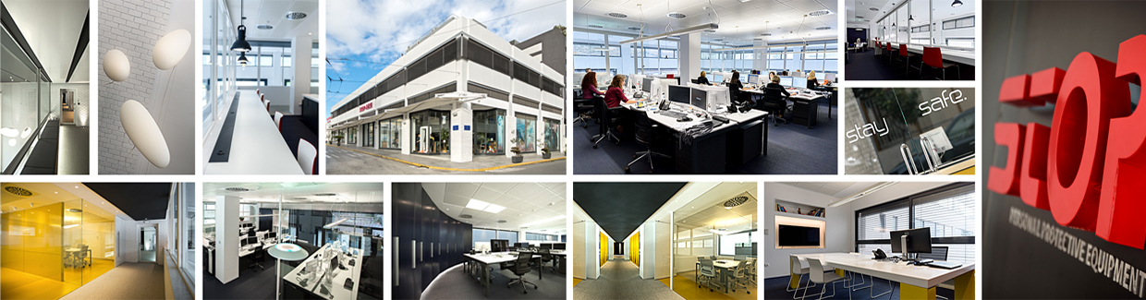
Work Location: Piraeus
STOP SA (www.stop.gr), specializes for more than 40 years in the Personal Protective Equipment (PPE) Industry holding a leading position in the Greek PPE market with headquarters in Piraeus, a branch in Rotterdam and 3rd party hubs in Singapore, Manila, UAE, Nigeria and Cyprus.
We have a high respect of our current and future employees by building relationships based on mutual trust, support, honesty and safety, while encouraging the freedom of opinion and expression.
If you enjoy working for a company that cares about people, pays attention to their wellbeing (including a life and medical plan and state-of-the-art facilities) and focuses on the development of their capabilities, knowledge and competencies,
JOIN US!

STOP is an equal opportunities employer, treats all CVs with full confidentiality and respects the General Data Protection Regulation (GDPR).

We will be more than happy to receive your CV in English by 06 October 2019 at hr@stop.gr mentioning the position code LOM/0919.

