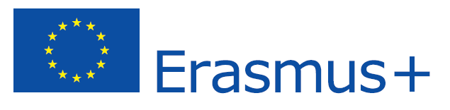

Erasmus Placements in BizPartner a.s.
Placement Description

COMPANY OVERVIEW
NAME OF THE COMPANY | BizPartner a.s.
ADDRESS | Dlhé Hony 6, 05801 Poprad
COUNTRY | Slovakia
WEB PAGE | www.updience.com, www.bizpartnergroup.com
SHORT INFORMATION ABOUT COMPANY | We are a young company with headquarter in Slovakia and with subsidiary in London UK. Our focuses are global marketing solutions and communication. Our motto is: “Scale your business!”
CONTACT PERSON | Martin Fodor
CONTACT DETAILS  (E-MAIL, TEL. NO.) | hr@updience.com, 00421911660535
REQUESTED ERASMUS STUDENT PROFILE | Erasmus student
FIELD OF STUDIES/PROFESSIONAL AREAS OF INTEREST | Marketing, management, media, strategy marketing, project management, graphic designer
TASKS | Online communication, social media, marketing articles ideas, customer support, Graphic tasks :creation of visual, interactive and multimedia designs, creating online marketing visuals - Graphic mails, online banners
REQUIREMENTS (LANGUAGES AND OTHER COMPETENCES) | ENG
PAYMENT OR OTHER BENEFITS | Accommodation – free
PLACEMENT DURATION | 3-6 months
PLACEMENT PERIOD  (FROM - TO) | From 09/2015
OTHER INFORMATION | ---------------------

