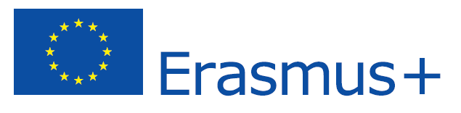
ERASMUS+ PLACEMENT OFFER IN LATVIA

EMPLOYER INFORMATION
Name of organization | RISEBA University
Address | 3 Meza Street
Postal Code | LV-1048
City | Riga
Country | Latvia
Telephone | +37167500265
Fax | +37167500252
E-mail | riseba@riseba.lv
Website | www.riseba.lv
Number of employees | 70
Year of foundation | 1992
Contact person | Ms Galina Zilgalve
Department / Function | External Relations Department
Direct telephone number | +37167500256
Direct mobile | -//-
Direct e-mail address | galina.zilgalve@riseba.lv
Short Description of the Company | RISEBA is a university type private higher educational institution fully accredited by the Ministry of Education and Science of the Republic of Latvia.  Being one of the first private higher education institutions in Latvia, today RISEBA is among 10 largest higher education institutions in Latvia (both public and private) with 3000 students, including 200 international students, who attend 17 study programmes of different levels and directions, and more than 9000 alumni.  Over the last two decades RISEBA has gone through a substantial transformation from a small ambitious business school to the university that provides, in addition to business and management programmes, studies in communications, audiovisual media arts and architecture, thus transforming the institution into “the place where business meets arts”.

PLACEMENT INFORMATION
Department / Function | External Relations Division Assistant
Description of activities | Daily assistance to External Relations Division’s staff  Provide support for events organised by RISEBA External Relations Division, such as Orientation days, summer schools, etc.  Preparation of communication materials for mass media and Social Media  Work with the university home page  Customer Service: communication with international students (ongoing communication on student and study related issues)  Conducting desk research (gathering and analysing information, available in print and published on the internet)  Cooperation with other RISEBA structural units and staff, e.g. Student Council, Study Department, Programme Directors, etc.
Duration | Min 3 months
Working hours / Weekly hours | 8h per day; 40 h per week
City | Riga
Help with finding Accommodation | Yes
Financial Contribution | No
Other | This is an unpaid position. ONLY candidates eligible for scholarships (Leonardo, Erasmus, etc...) will be considered.

REQUIREMENTS
Oral and written language skills | English (level: C )  Knowledge of other EU languages welcome
Computer skills | Good knowledge of Microsoft Office tools
Other | Time management, communication skills (both written and spoken), pro-activity, accuracy, sense of responsibility and efficiency

APPLICATION
Please send your CV and Motivation letter to galina.zilgalve@riseba.lv by 01 March 2015

