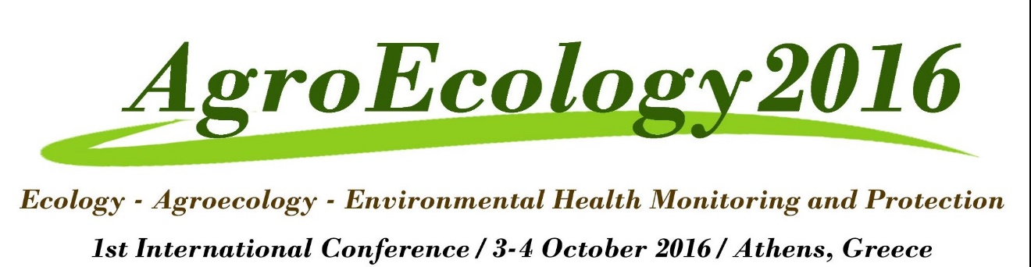

Conference Programme

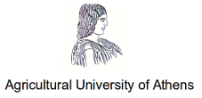

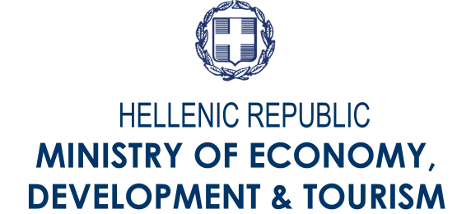
Under the auspices of:

International Scientific Committee

International Members
Arapis Gerassimos / Greece_ Department of Crop Science - Agricultural University of Athens
DeRuiter Peter /Netherlands _ Institute for Biodiversity and Ecosystem Dynamics – University of Amsterdam
Diakosavvas Dimitris / France _ Organisation for Economic Co-operation and Development (OECD)
Helenius Juha / Finland _Department of Agricultural Sciences - University of Helsinki
Kalfagianni Agni / Netherlands _ Copernicus Institute for Sustainable Development
Kephaliacos Charilaos / France _ National Teacher Training School in Agronomy
Köpke Ulrich / Germany _ Institute of Organic Agriculture - University of Bonn
Markert Bernd / Germany_Environmental Institute of Scientific Networks (EISN-Institute)
Mattiello Silvana / Italy _ Department of Animal Science, University of Milan
Mendes Moreira Pedro Manuel / Portugal _ Escola Superior Agrária de Coimbra (ESAC)-Instituto Politécnico de Coimbra
Pedersen Søren Marcus / Denmark _ Section for Production, Markets & Policy - Copenhagen University
Peeters Alain / Belgium _ RHEA - natural Resources, Human Environment and Agronomy
Rae Jon / USA _ Schumacher College
Research Centre
Šťastná Milada / Czech Republic _ Faculty of Agronomy - Mendel University in Brno
Suso María José / Spain _ Institute for Sustainable Agriculture – Spanish National Research Council
Tornaghi Chiara / UK _ Centre for Agroecology, Water and Resilience (CAWR)
Vellidis George / USA _ Crop and Soil Sciences Department - University of Georgia
Vicente Oscar / Spain _ Department of Biotechnology - Polytechnic University of Valencia (UPV)
Wright Angela / UK _ Compassion in World Farming

National Members
Bebeli Penelope / Greece _ Department of Crop Science - Agricultural University of Athens
Bilalis Dimitris / Grece _ Department of Crop Science - Agricultural University of Athens
Economou Garifalia / Greece_ Department of Crop Science - Agricultural University of Athens
Fountas Spyros / Greece _ Department of Natural Resources Management & Agricultural Engineering - Agricultural University of Athens
Hatjigeorgiou Ioannis / Greece _ Department of Animal Science & Aquaculture - Agricultural University of Athens
Nikolaidis Nikolaos / Greece _ Department of Environmental Engineering - Technical University of Crete
Papadakis George / Greece _ Department of Natural Resources Management & Agricultural Engineering - Agricultural University of Athens
Paravantis John / Greece_ Department of International & European Studies - University of Piraeus
Perdikis Dionysios / Greece_ Department of Crop Science - Agricultural University of Athens
Rozakis Stelios / Grece _ Environmental Engineering Dept.- Technical University of Crete
Saitanis Constantinos / Greece_ Department of Crop Science - Agricultural University of Athens
Savvas Dimitris / Greece_ Department of Crop Science - Agricultural University of Athens
Sigrimis Nick / Greece _ Department of Natural Resources Management & Agricultural Engineering - Agricultural University of Athens
Thanopoulos Rhoikos / Greece _ Department of Farm Management -Agricultural University of Athens
Veresoglou Dimitrios / Greece _ School of Agriculture - Aristotle University of Thessaloniki
Vlahos George / Greece _ Department of Agricultural Economics & Rural Development - Agricultural University of Athens

Venue: | Agricultural University of Athens (AUA), 75 Iera odos str., 118 55, Athens-Greece
Room: | General Purposes' Room of the Administration Building. – Agricultural University of Athens
Language: | English
Info : | agroecology2016@gmail.com
Agenda

Day 1 (October 3rd, 2016)
 | Opening of the conference – Welcome reception
9:00-10:00 | Registration – Welcome coffee
10:00-10:15 | Opening  Rector or Vice Rector, Agricultural University of Athens (AUA)  Prof. Gerassimos Arapis, Agricultural University of Athens (AUA)
10:00-13:00 | Session 1: Ecology  Moderator: Prof. George Vlahos, Department of Agricultural Economics & Rural Development - Agricultural University of Athens
10:00-11:20 | Effect of Spinosad and Spinetoram on Ground-Dwelling Spider, Mite, Coleopteran, Collembolan, Ant and Harvestmen Communities  F. G. Lefkaditis, N. G. Kavallieratos, C. G. Athanassiou, G. D. Arapis  Response of organic Camelina sativa crop under different tillage systems and fertilization types  F. Angelopoulou, E. Anastasiou, S. Fountas, D. Bilalis  A photosynthetic biosensor for the detection of PSII herbicides using immobilized thylakoids of the bioindicator Lemna minor on screen printed electrodes  A.C. Mouzaki-Paxinou, E. Flampouri, S. Mavrikou, S. Kintzios, G. Arapis  Discussion
11:20-11:30 | Coffee break
11:30-13:00 | Bayesian decision support tools for cost-effective environmental abatement on dairy farms  S. Nisonen  Impact of organic practices on greenhouse gas emissions by three local faba bean landraces  V. Vougeleka, G. Ntatsi, V.A. Pappa., P.J. Bebeli.,C. Saitanis., G. Arapis.,D. Savvas  Enhancing plant nutrition via S0-based rhizosphere engineering – Convertion of conventional commercial fertilizer beads to functional ones by coating them with elemental sulfur via a new eco-friendly technology  S. Chorianopoulou, A. Venieraki, G. I. Saridis, F. Maniou, M. Margetis, P. Sigalas, H. Mavrogiannis, D. Benardos, P. Katinakis, D. Bouranis  Discussion
13:00-14:00 | Lunch
14:00-17:00 | Session 2: Agroecology  Moderator: Scientific Committee Member (tbc)
14:00-15:20 | Invasive weeds and herbicide resistance: the case of Conyza spp. in Greece  I.S. Travlos, D. Bilalis, Ch. Gavrielatos  Antiparasitic activity of tannin-rich Mediterranean plants against sheep gastrointestinal nematodes: in-vitro studies  K. Saratsi, Z. Paris, I. Hadjigeorgiou, S. Sotiraki  Socio-economic and cultural aspects of the assessment of livestock breeds' risk status and trends  Ch. Ligda, E. Sturaro, E. Charvolin, M. Castellanos, Z. Duchev, S. Winkel, F. Afonso, M. Cornejo, G. Gandini, E. Verrier  Discussion
15:20-15:30 | Coffee break
15:30-17:00 | The role of Agroecology to promote sustainable schemes of Agrotourism and Ecotourism  C. Fostieri  Dry-stone buildings supporting biodiversity in rural areas  E. Stathopoulou  Agroecology principles adoption in dairy industry of Greece: Actions for the GAIA project  I. Hadjigeorgiou, E. Fortatos, T. Chatzigeorgiou, G. Zervas  Discussion
Day 2 (October 4th, 2016)
10:00-13:00 | Session 3: Environmental Health Monitoring and Protection  Moderator: Prof. Silvana Mattiello _ Department of Animal Science, University of Milan
10:00-11:20 | Developing a strategy for landraces’ on farm conservation  R. Thanopoulos, P.J. Bebeli  A toxicogenomics approach for the monitoring of environmental health using Lemna minor L. as the model biological system  S. Kostopoulou, K.A. Aliferis, G. Arapis  Accuracy of Pitfall-Traps in Estimating Density of Ground-Dwelling Arthropods under Treatment with Spinosyns and Chlorpyrifos: a Field Study  F. G. Lefkaditis, C. G. Athanassiou, N. G. Kavallieratos, G. D. Arapis  Discussion
11:20-11:30 | Coffee break
11:30-13:00 | The EU Regulation Nr. 2283/2015 on Novel Food: The Official Control of the Engineered Nanomaterials Food to Guarantee Public Health and Safety and Protection of the Environment  G. Ruffo, P. Fossati  The Importance of Hippocrates Medicinal Plants (MPs) as Phytochemical Pool  E. Fanouriou, E. Gavriil.,P. Tarantilis, K. Sotirakoglou, P. Trigas, D. Kalivas, G. Economou  Application of the microdialysis technique for monitoring low molecular weight compounds in soils: a non-targeted and targeted profiling in the organic horizon of a boreal forest  D. Randewig, J. Marshall, S. Jämtgård, T. Näsholm  Discussion
13:00-14:00 | Lunch
14:00-17:00 | Session 4
Session 4-1: Round Table “Sustainable development of Agrotourism and Ecotourism in Greece”
Moderator: Professor Gidarakou Isabella _ Dept. of Agricultural Economics and Rural Development, Agricultural University of Athens.
Participants:
Professor Migiros George _ Mineralogy and Geology Laboratory of the Agricultural University of Athens
Patras Panagiotis _ Agroeconomist / Trikala Development Company, Greece
Moros Konstantinos _ Amfikaia Agro/Ecotouristic Farm, Greece
Minotou Charikleia _ WWF Representative, Greece Representative of the Ministry of Agriculture, Greece (TBC)
Hellenic National Tourism Organization Representative (TBC)
Piraeus Bank Representative (TBC)
 | Session 4-2: Posters’ presentation
Session 4-3: Conclusions & Way Forward
Prof. Gerassimos Arapis, Agricultural University of Athens (AUA)

